***Document Movie API***

* API

+End point Save (**POST**): <http://localhost:1919/api/movie/save>

Request Body:

{

    "title":"fail in love",

    "category":"khmer movie",

    "starRating":0.5

}

+End Point FindById (**GET**): <http://localhost:1919/api/movie/10>

Response:

{

    "id": 10,

    "title": "true love",

    "category": "Korea",

    "starRating": 0.5

}

+End point retrieve a list of movies (**GET**): <http://localhost:1919/api/movie/listMovie>

Response:

[

    {

        "id": 8,

        "title": "true love",

        "category": "Korea",

        "starRating": 0.5

    },

    {

        "id": 9,

        "title": "test",

        "category": "Thai",

        "starRating": 5

    },

    {

        "id": 10,

        "title": "true love",

        "category": "Korea",

        "starRating": 0.5

    }

+End point Update (**PUT**): <http://localhost:1919/api/movie/update/11>

Request Body:

{

    "title":"fail in love",

    "category":"khmer ",

    "starRating":5

}

{

    "title":"fail in love",

    "category":"khmer",

    "starRating":5

}

+End point (**DELETE**): <http://localhost:1919/api/movie/delete/7>

Response:

id : 7 delete successful!

* 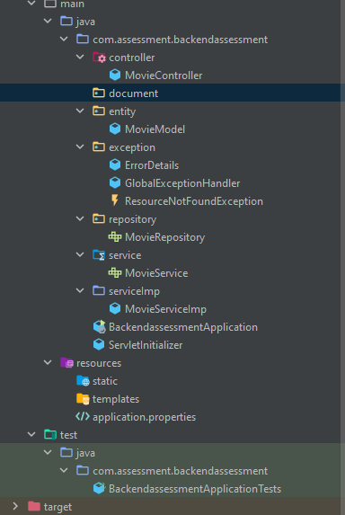 Class for test Junit